Adaptive Cable Equalizer

# Javad Nematli r0771945

**Build-up:**

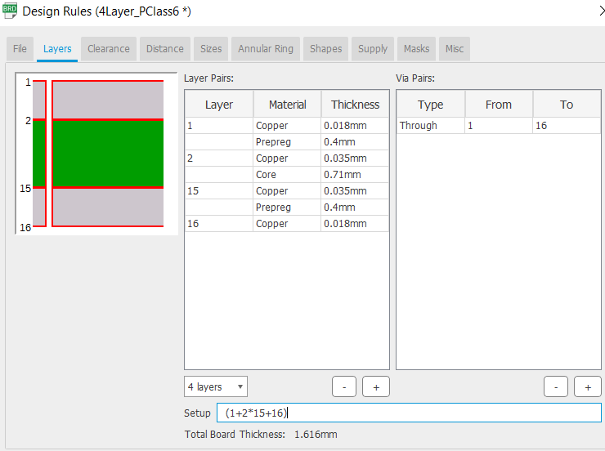

**50 Ohm transmission line:**

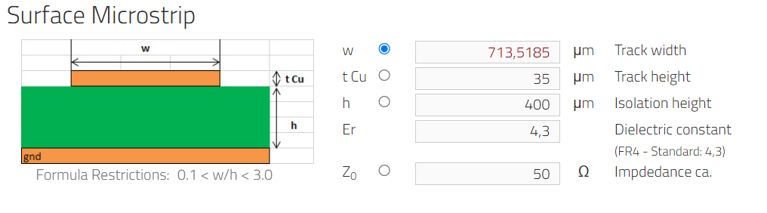

**75 Ohm transmission line:**

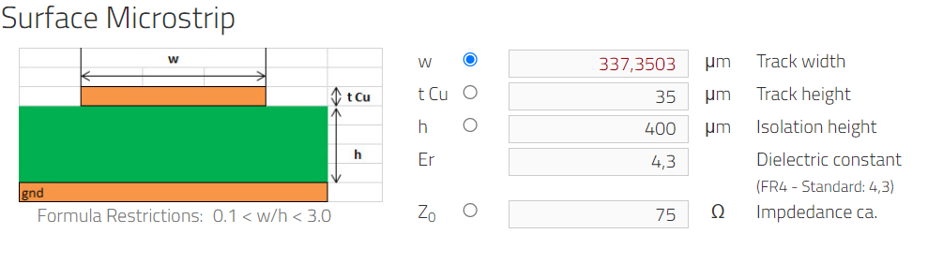

**Net classes:**

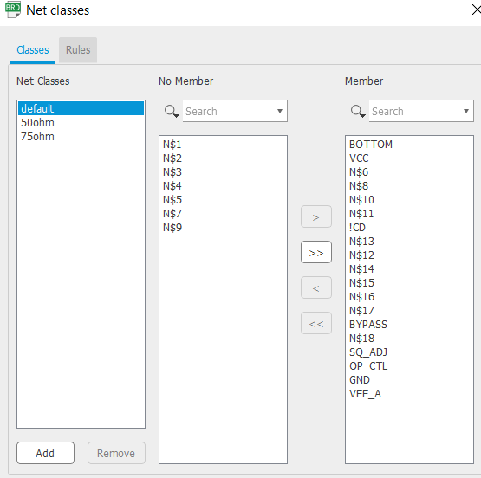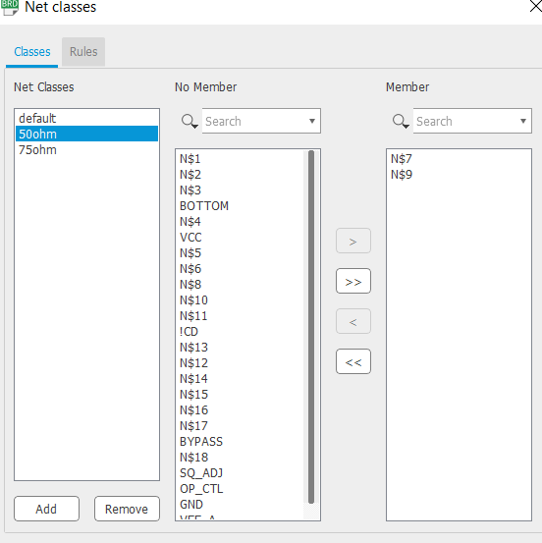

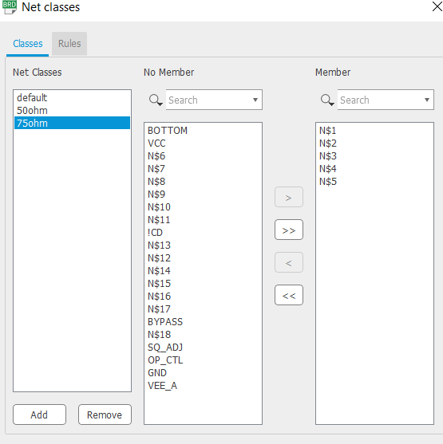

**Layers:**

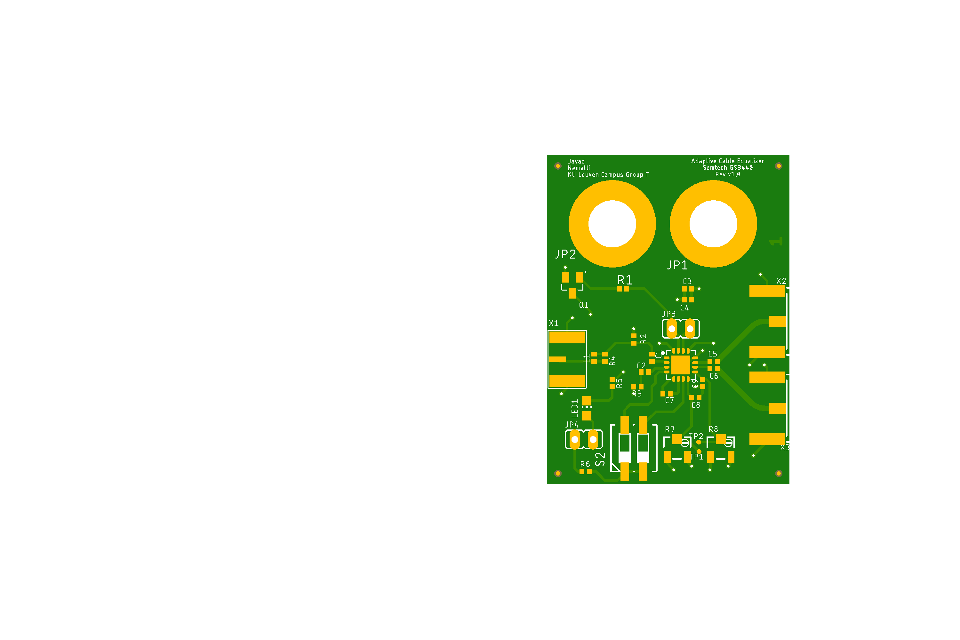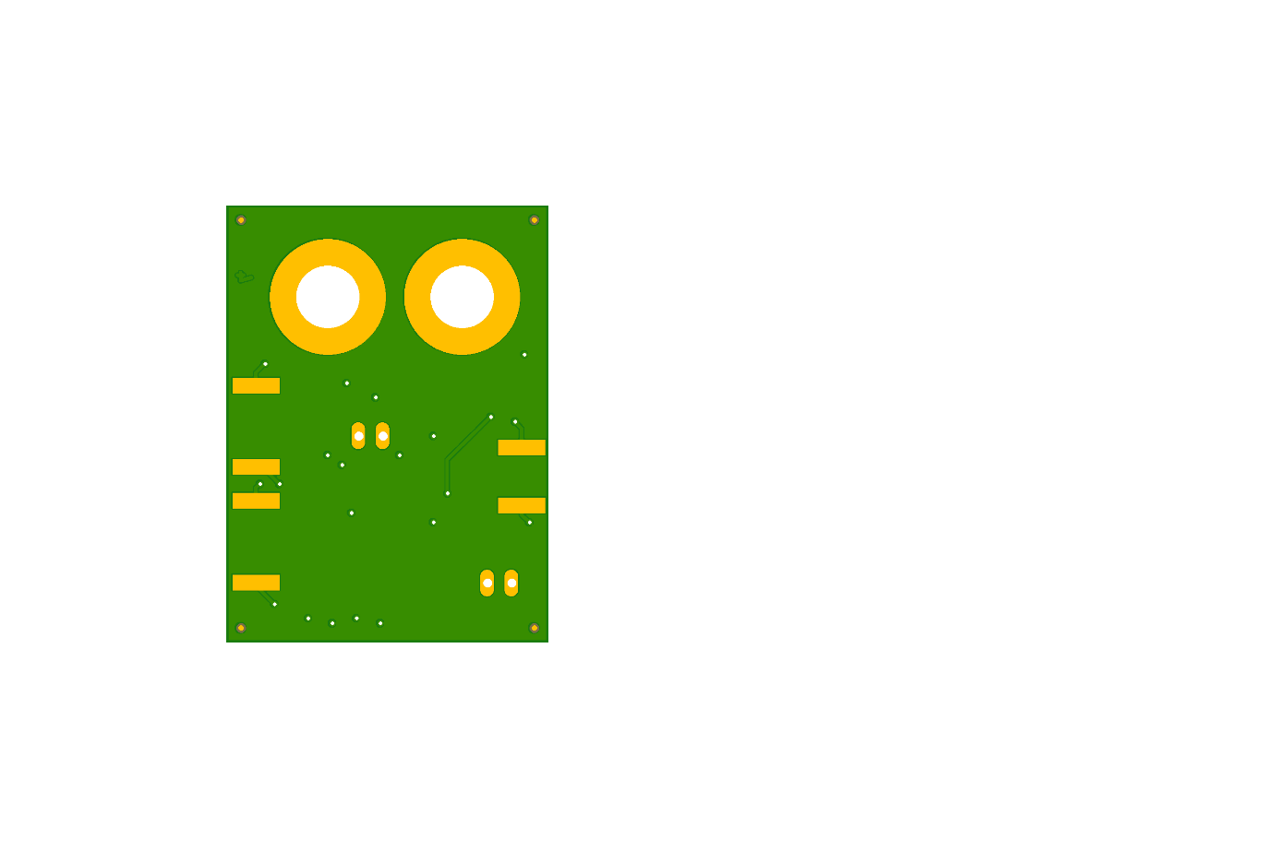

**Design rules:**

* The outputs should be symmetrical, the transmission lines at the output should be of the same size.
* Put components closer to the IC to minimize loop area.
* Put decoupling capacitors for Vcc to reduce noise.
* Put transistor to the side of the PCB for the possibility to attach a heat sink.
* Thermal spacing (already mentioned in the DRC).